**The Bandmap**

# Geoff Anderson  G3NPA, Jim Hargrave W5IFP and Aki Yoshida JA1NLX

## 1.0 GENERAL

.

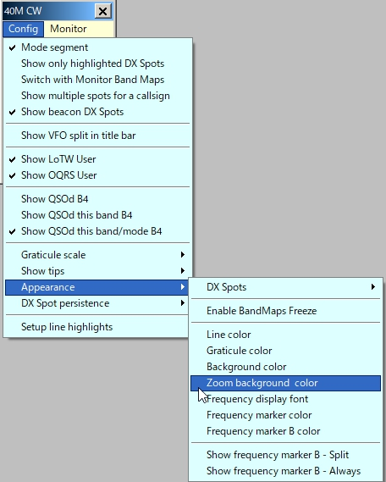

TBM_16

### 2.2 Monitor

15 ~~Ten~~ monitor Bandmap windows are available to monitor. Bandmap windows are available to allow the user to monitor activity on bands other than the one currently being used (for example; a permanent activity monitor for 6M and 10M regardless of what/where the operator is doing). Clicking on the "Monitor" menu option on the main Bandmap will produce the additional display menu as shown below.

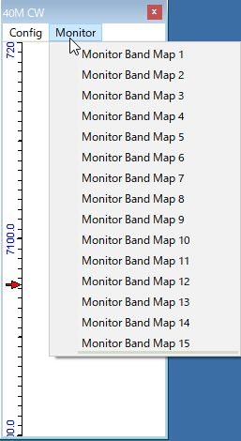

new TBM_10

The user can click on a DX Spot on the Monitor Bandmap and the Radio (if connected) and the Logbook Entry window will QSY to the frequency/mode. The Monitor Bandmap will switch when the user changes bands on the radio, or the radio changes band for whatever reason (clicking on a DX spot, clicking on a Monitor Bandmap, or whatever) to the band the radio was on (before the QSY) provided the "Switch with Monitor Bandmaps configuration" option is checked. If this option is unchecked, then the monitor windows will not change over with the main bandmap and will therefore continue to display spots for the selected band.

2.2.1 Config Menu

All config settings for the Monitor Bandmap are identical to those of the main except the Highlight line is not applicable.

### 2.2.2 Band

It is here where the user selects the band to monitor.  **Note** that the bands listed here are derived from the BandMode table and will differ according to user preferences and setup.